## aMerchant

Demo date: Nov 14, 2024  
Scoping start date: Nov 14, 2024

MSA Signature Date: Dec 31, 2024  
Onboarding Kick Off Date: Jan 8, 2025

[If Exists] Opt Out Date: Oct  
Go Live Date: Apr 1, 2025

GTM POC: Jarrett  
Implementation POC: Royce

ERP: QBO

Tax Integration: Avalara

### 

### Key people at Merchant

* Controller: Anthony Posillico <[posillico@revolutionparts.com](mailto:posillico@revolutionparts.com)>
* CFO: Gopal Mehta gmehta@revolutionparts.com
* Business System Manager: [Allan Untalan](https://www.linkedin.com/in/allan-untalan/overlay/about-this-profile/) auntalan@revolutionparts.com

### 

| Notes Sections [Ops International Team to Ignore] *(AE/ Implementation to fill)*   * Info on how merchant bills   + 600-800 customers.   + Platform, % of GMV, and amount of packages * Key documents:   + [RevParts <> Tabs Solution Summary](https://docs.google.com/presentation/d/110MGATjEvYqQmgDc_jpZ-7r6c5WFdJavemnxu-dXkgo/edit?usp=sharing)   + [RevParts <> Tabs Exec Meeting](https://docs.google.com/presentation/d/1ofCatWmeHgKkszNflhuk7CdrWdBx4Tq1A_9Qfs6TaWA/edit#slide=id.g2f23a7ee887_1_452)   + [RevolutionParts // Tabs (Tabs Version)](https://docs.google.com/presentation/d/1237czr8ZWfn3oxBIer32kq-LigYQvU9NpfStpXoEnXU/edit?usp=sharing)   + [Tabs <> Revolution Parts SOW](https://docs.google.com/document/d/1eB_fDNJLkfwDL8ozr1WhRbNWuYa1mY6oGoufVAWKsN4/edit?tab=t.0) This is an outline of an implementation- it was presented as directional and not an actual plan to the client      * Is there any important merchant relationship information?  1) What is the merchant temperament? * Anthony is awesome- a really great partner. They work very hard on their end   2) Is there a key POC: (i.e.: who is the buyer/decision maker?)   * You will likely be working closest with Anthony and Alan   3) What are the Tabs features that the key POC cares about?   * API connection to their platform, SDFC connection |
| --- |

### Company summary *(AE to fill)*

**Summary of what company does:**

We make it easy for dealers/manufacturers to sell parts and accessories online with our catalog and eCommerce solutions.

Goals (North star)  
*(AE/ Implementation to fill)*

**What is the merchant's goal? What pain are we solving? Why are they buying Tabs?**

Anthony was hired to overhaul their billing process: Very manual process to to tabulate their invoices that lead to error. They are platform and usage and based on GMV- more details to follow.

**Is there an opt out clause? If so, what is the merchant looking for so they do not exercise it?**

Yes, that is in the event there are business changes on their end, and it is not tied to Tabs performance. 90 day opt out (should be before the go-live date)

### Billing model *(AE/ Implementation to fill)*

* Are there unique things about the customer creation process for this merchant?

n/a

* Information on how merchant bills
* There was nothing out of the ordinary or difficult about their usage needs. Currently, they maintain a usage spreadsheet (rate + event) and feed it into FreshBooks to calculate invoices. This process is clunky, manual, and prone to errors by the time it reaches the finance team’s desk (e.g., mismatched rates, etc.).
* See their usage spreadsheet and O2C process map here. They’re very open to replacing FreshBooks with a more modern solution and love that Tabs maintains the rate card and includes an audit element.
* How contract is broken up

n/a

* One off things to know about the merchant

They are currently doing some short sprints to clean up SFDC- it should not conflict with Tabs work.

### Contract Processing Steps *(Implementation/Success to fill)*

* General
  + RevParts uses Billing Profiles that determine the processing instructions

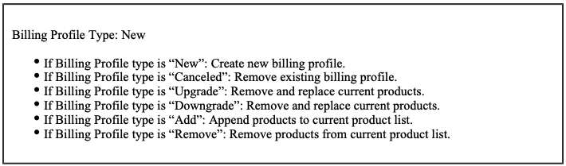

* + The Billing Profile for the contract will be next to “Billing Profile Type:” in the top left
  + Follow the instructions below for each Billing Profile type
* Additional instructions
  + If the contract has a salesforce ID in any of the “Bill to” fields
    - 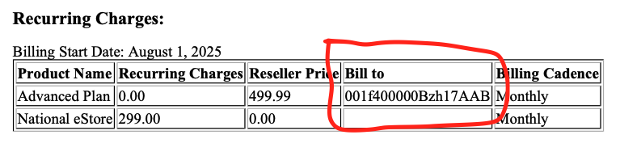
      * Open [this sheet](https://docs.google.com/spreadsheets/d/1F1Px9Z-E7bLJLHH0GEsUVce07OSvZhItJovRs_Z1eXs/edit?usp=sharing)
      * Go to Mapping (Billed to & Used by) tab
      * In Column C -> put the name of the customer at the top of the profile
      * In Column Q (Used By Salesforece ID) -> put the salesforce ID at the top of the contract
        + 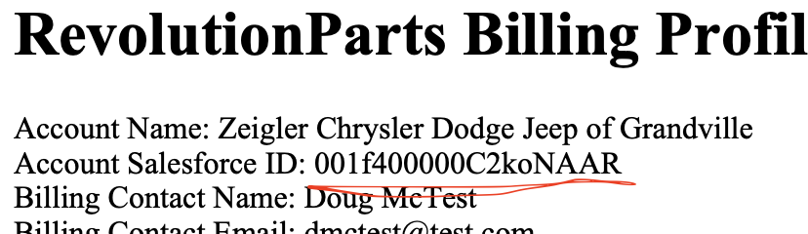
      * In Column R (Billed-To Salesforce ID), put the Salesforce ID in the “Bill To” section of the billing terms in the orange screenshot above
      * Lastly, for all products *that have a salesforce ID in the Bill To section* (orange screenshot), put a 1 for the product name for columns D-P. If it isn’t a 1, put a 0.
* **Billing Profile Type: New**
  + Need to pay attention to the “Billing Products and Terms” section

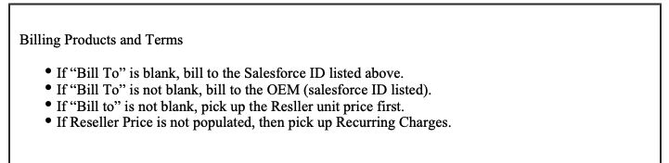

* + If “Bill To” *is blank*, bill to the Salesforce ID listed above.
    - This means to process as normal and create the BT for that contract
  + If “Bill To” *is not blank*, bill to the OEM (salesforce ID listed).
    - Will require duplicating the contract in garage, processing that BT, and assigning to the customer that corresponds to that salesforce ID



* This BT will need to go under a different customer -> You will need to first DUPLICATE the contract in garage to process this BT (do not create this BT for the existing contract)
  + [Example of original contract](https://garage.tabsplatform.com/prod/contracts/95f1c849-cc9b-4801-adec-7e9fb128a38d/preview)
  + [Example of duplicated contract](https://garage.tabsplatform.com/prod/contracts/67d523b8-6632-4941-9a37-5cc500381764/terms/key)
    - Instructions for duplicating the contract and assigning the correct customer (recommendation: do this step last after all the BTs have been processed for the customer in the contract)
      * First duplicate the contract in garage

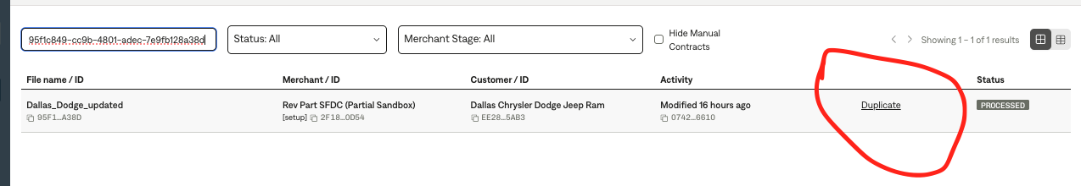

* + - Make sure none of the other BTs from the original contract are duplicated
      * Should only be the BT with the Salesforce ID in “Bill to” in the above screenshot
    - Next, find the customer that needs the billing term
      * Open this [google sheet](https://docs.google.com/spreadsheets/d/1HxvUHl_NE8ym3kpldc_xSvDsIkQ3FT-UFNFn1K53dtQ/edit?usp=sharing)
      * Copy the Salesforce ID that is listed in the “Bill To” section of the billing item
        + Looks something like this: 001f400000AbASZAA3
      * Search the google sheet and find the customer ID that matches with the external ID
      * If you can’t find the customer, flag to [Marshall Morrison](mailto:marshall@tabsplatform.com) in slack so that he can search the live [Omni dashboard](https://tabs.omniapp.co/dashboards/d1e6b71e) and add to the google sheet
    - Paste that customer ID in the customer field of the duplicated contract
    - Process the BT
      * **\*\*\*Use the *Reseller Price* for the price of the the BT**
        + Per contract language: *“If “Bill to” is not blank, pick up the Reseller unit price first.”*
      * If Reseller Price is $0, you will use the Recurring Charges price
        + Per contract language: *“If Reseller Price is not populated, then pick up Recurring Charges.”*
  + Item Name:
    - Use the product or service name from the contract line item
    - Please complete the spelling if a word is cut off.
      * Example: “Shipping Prtection” should be corrected to “Shipping Protection”
  + Quantity: follow the contracts Probably will be 1 for all Flat BTs
  + Total Price:
    - Make sure to follow those “If” statement instructions at the top
    - Example for Recurring charges:
      * If "Bill to" is populated, use Reseller Price
      * If the Reseller Price is $0, use the Recurring Charges value
    - For Variable charges:

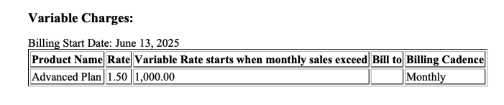

* + - * This will be a tiered usage BT
      * The Variable Rate column is the tier quantity
      * The rate is the percentage price (needs to select use % for the event)
      * The above screenshot would be 1.5% unit rate applied when >= 1000 quantity

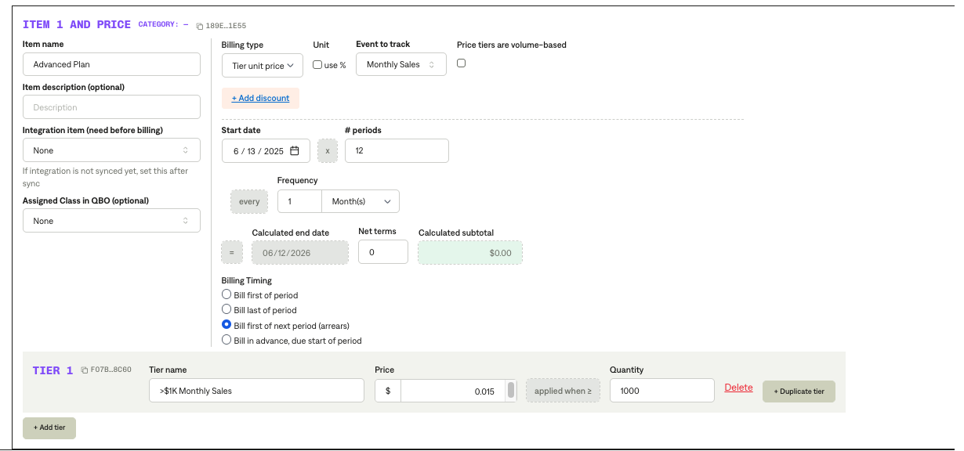

* + - For Pass-through charges (these are Unit BTs): Use unit price listed in $
    - Exclude $0 BTs or any BTs without a price listed
* Billing Start Date
  + Use the date listed under each billing section header in the contract:

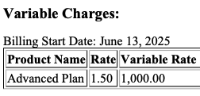

* Service Start Date: same as billing start date
* Months of Service
  + Use the months implied by the data range



* + Typically will be the “Contract Term in months” at the top but follow the ranges if they don’t match up
  + If you see no end date (one-time fees), use 0 months
* Frequency
  + Stated in “Billing Cadence” column
  + Can assume the frequency for Pass-through Charges frequency is the same as Variable and Recurring if not listed
  + One-time fees: None
* Net Terms: Always 0
* **Billing Profile Type: Cancel**
  + Find the original contract for the customer AND for the “Bill To” salesforce ID and shorten the products to the date the cancel contract was uploaded.
    - Shorten the products so that the next invoice doesn’t go out
    - To find the salesforce ID (“OEM”) products, find the contract that got duplicate for that salesforce ID (if it exists on the original contract)
      * Shorten those products IN ADDITION, to shortening the BTs for the dealer (customer name on the contract)
* **Billing Profile Type: Upgrade and Downgrade (Cancel + New Contract)**
  + For the billing and service period dates of the new BTs
    - Find the original dealer contract that it is modifying, and use the end date of that contract.
    - The start date will be when the next invoice would have gone out
      * So if the old contract bills on the 15th and end 12/31
      * The next BTs should start on the 15th of the next invoice and end 12/13
  + Find the (correct) original contract for the customer (dealer) AND the OEM (bill to: salesforce ID) and shorten the products for BOTH to end before the upload date of the upgrade and or downgrade contract
    - Locate the customers previous contract to cancel and the locate contract that was duplicated for the bill to salesforce ID (OEM) and cancel those products as well
    - Make sure to do this under the correct contract. For example,
      * Downgrade contract: “Billing_Profile_Test_-_NNA_**Silver_Plan** (Downgrade).pdf”
      * Available contracts processed in garage
        + Billing_Profile_Test_|_NNA_Platinum_Plan.pdf (Ignore)
        + Billing_Profile_Test_-_NNA_Gold_Plan.pdf (Ignore)
        + Billing_Profile_Test_|_NNA_**Silver_Plan**.pdf (this is the one we should delete BTs for)
      * Need to make sure we are picking the correct file if there are multiple to modify. Use the file name to match it up
  + Process the Upgrade/Downgrade products under the upgrade/downgrade contract
    - Follow the appropriate instructions if Bill To isn’t blank
* **Billing Profile Type: Add**
  + Process as if it were a new contract
* **Billing Profile Type: Remove**
  + Find the original contract for the customer and shorten the products that are listed in the Remove contract to end before the date listed in the remove contract. It will only be the select few products listed in the remove contract.

1. Anything to ignore in contracts?
2. Specifics processing things the merchant has requested that may differ by contract (e.g. always back-date invoice date to final day of the month)
3. Default Service Term
   1. If None Listed, Ops Default is 1 Year
4. Default Net Payment Terms
   1. If None, Ops Default is 0
5. Default Billing Frequency
   1. If None Listed, Ops Default is Monthly
6. How do we handle taxes as a line item?
   1. If None Listed, Ops Default is every tax line item becomes a BT

### Events Processing (if necessary) *(Implementation/Success to fill)*

* Any important information on events billing

Integration Items Processing (if necessary)  
*(Implementation/Success to fill)*

* What are the instructions for assigning integration items?
* Example: All Statsig integrations items should be labeled as “Sales”
* Example: All “Pinata” integration items should be labeled as “Software Subscription Bundle” unless otherwise noted by Merchant

Post Processing Communications (if necessary)  
*(Implementation/Success to fill)*

* Does the Ops Team need to notify anyone on the team re: completion of processing batches in Implementation or Active phase?
* Who needs to be notified and when?
  + Example:
    - Who: Customer Success [Azmat Aziz] needs to be notified
    - Where: Messari internal merchant channel
    - When: contracts are processed [Merchant Phase: Active]

### Customer Information *(Implementation/Success to fill)*

* Any important information on specifics customers of this merchant
  + Special memo’s certain invoices require
  + Invoice changes due to merchant/customer relationship

### Feature Requests *(AE/Implementation/Success to fill)*

* API Connections
* The Hard Part:
* QBO is still their GL and everything is pushed there. But they’re using FreshBooks because it has much stronger API support than QBO for in-app payment details. So invoices are sent out of freshbook and all the billing info eventually ends up in QBO. The FreshBooks API interacts with the Revparts platform in two different ways that afre must haves for the Freshbooks team(see attached images):
* Invoice Overview Page
  + Displays the type of invoice: They typically send platform and variable charges as separate invoices since they may have different payment methods. We discussed supporting this with a parent/child relationship.
  + Date created
  + Total amount
  + Total outstanding
  + Invoice link, allowing the invoice to be paid directly
* Payment Management Page
  + Stores the payment method, which can be updated as needed
  + Includes an activity log tracking those changes

### Rewatch Calls *(AE/Implementation/Success to fill)*

* Nov 27 - <https://www.loom.com/share/e404d1c6cae24cb0af03c30c9f0e3edb>
* Dec 2- <https://www.loom.com/share/383a31ed8bc444a1ae0c468d2d2b62a8?sid=556da30d-9ec6-4f23-b4c9-d213a12e1b3b>
* Dec 3- <https://loom.com/share/575ddf64a17d4c67a3311dc0a3b2c794>